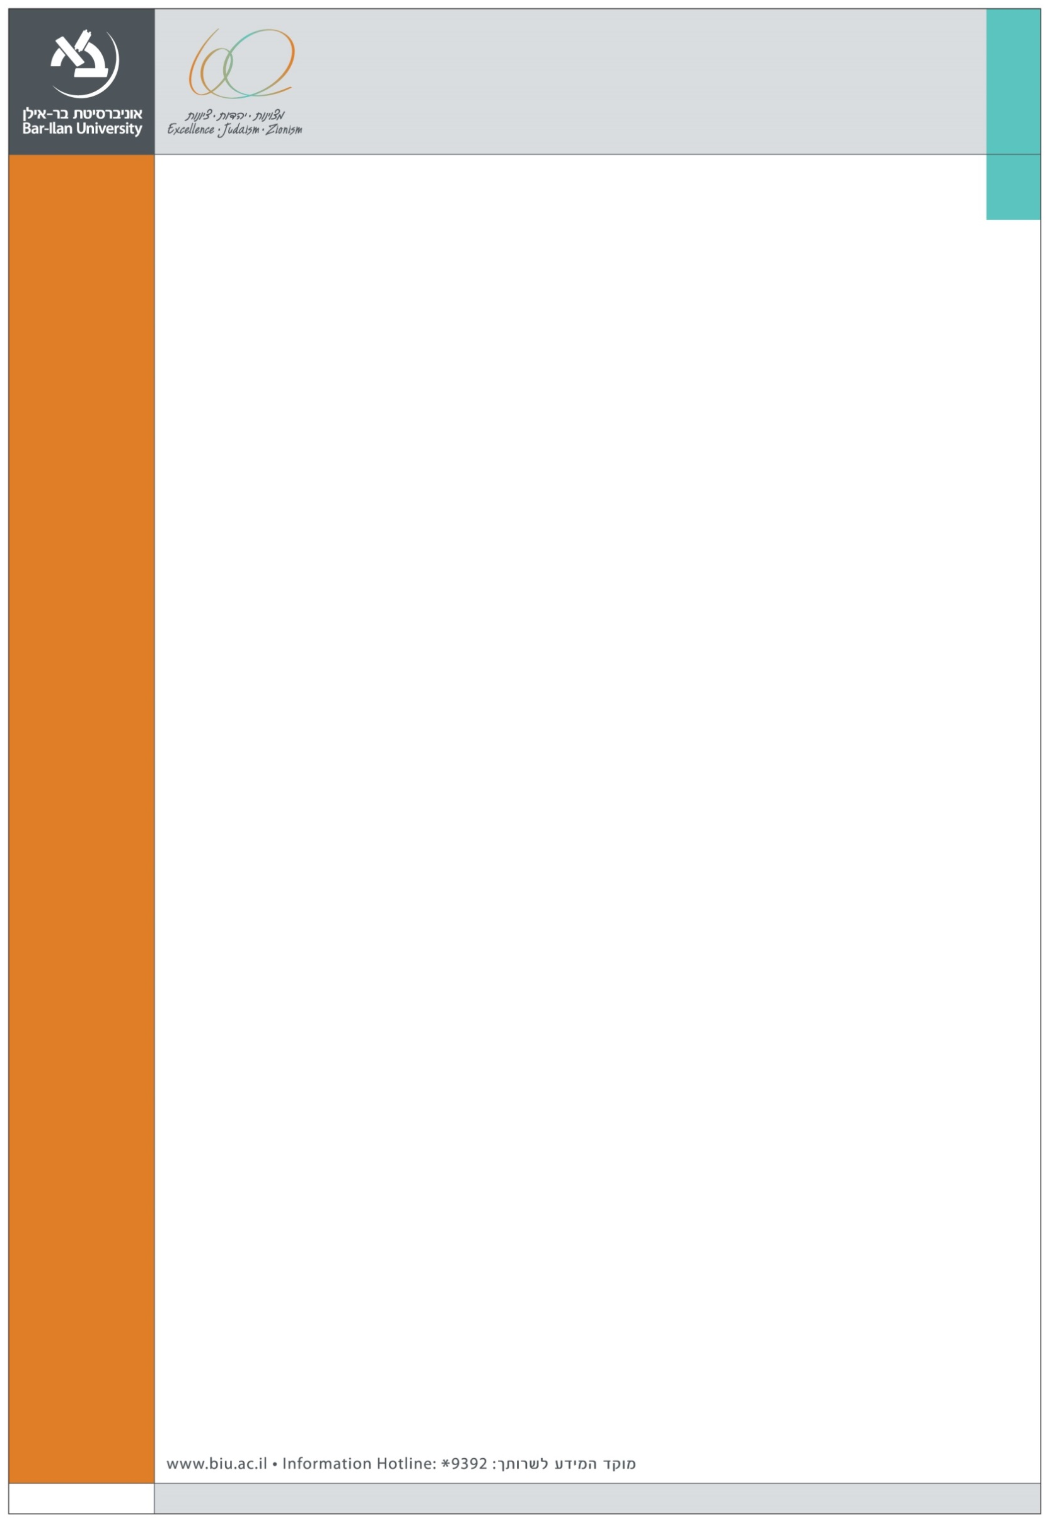
We are happy to announce the following Marketing seminar at the Graduate School of Business Administration

Speaker:
Ms. Merav Shoham
Technion – Israel Institute of Technology

Title:

Positively Useless: Irrelevant Negative Information
Enhances Positive Impressions

This research examines the impact of irrelevant information and its valence (positive or negative) on consumers’ evaluations and decisions. Focusing on the context of online reviews, it demonstrates that seemingly irrelevant reviews can enhance positive impressions, but only if they appear with a negative valence (e.g., with a one-star rather than a five-star rating).
The rationale for the proposed effect derives from research showing that consumers prefer well-reviewed options, but may seek additional cues in order to determine whether an option is indeed a good one. We suggest that the small number of negative reviews may function as such a cue, because negative information is perceived as being high in diagnostic value. Moreover, consumers tend to feel more confident about their attitudes when considering both positive and negative aspects during the decision process. A negatively valenced irrelevant review increases confidence in the completeness of the information, and because it does not provide the expected negative diagnostic value, it indicates that the product truly is a good one. This reinforces the positive impression and has positive implications for evaluations and decision-making.
A series of studies provides support for the proposed effect of irrelevant negative information on evaluations, choices and satisfaction. The underlying process of confidence in information completeness and the moderating role of information source are also examined.

Tuesday, December 13, 2016, 15:00
Room 301, Building 504

