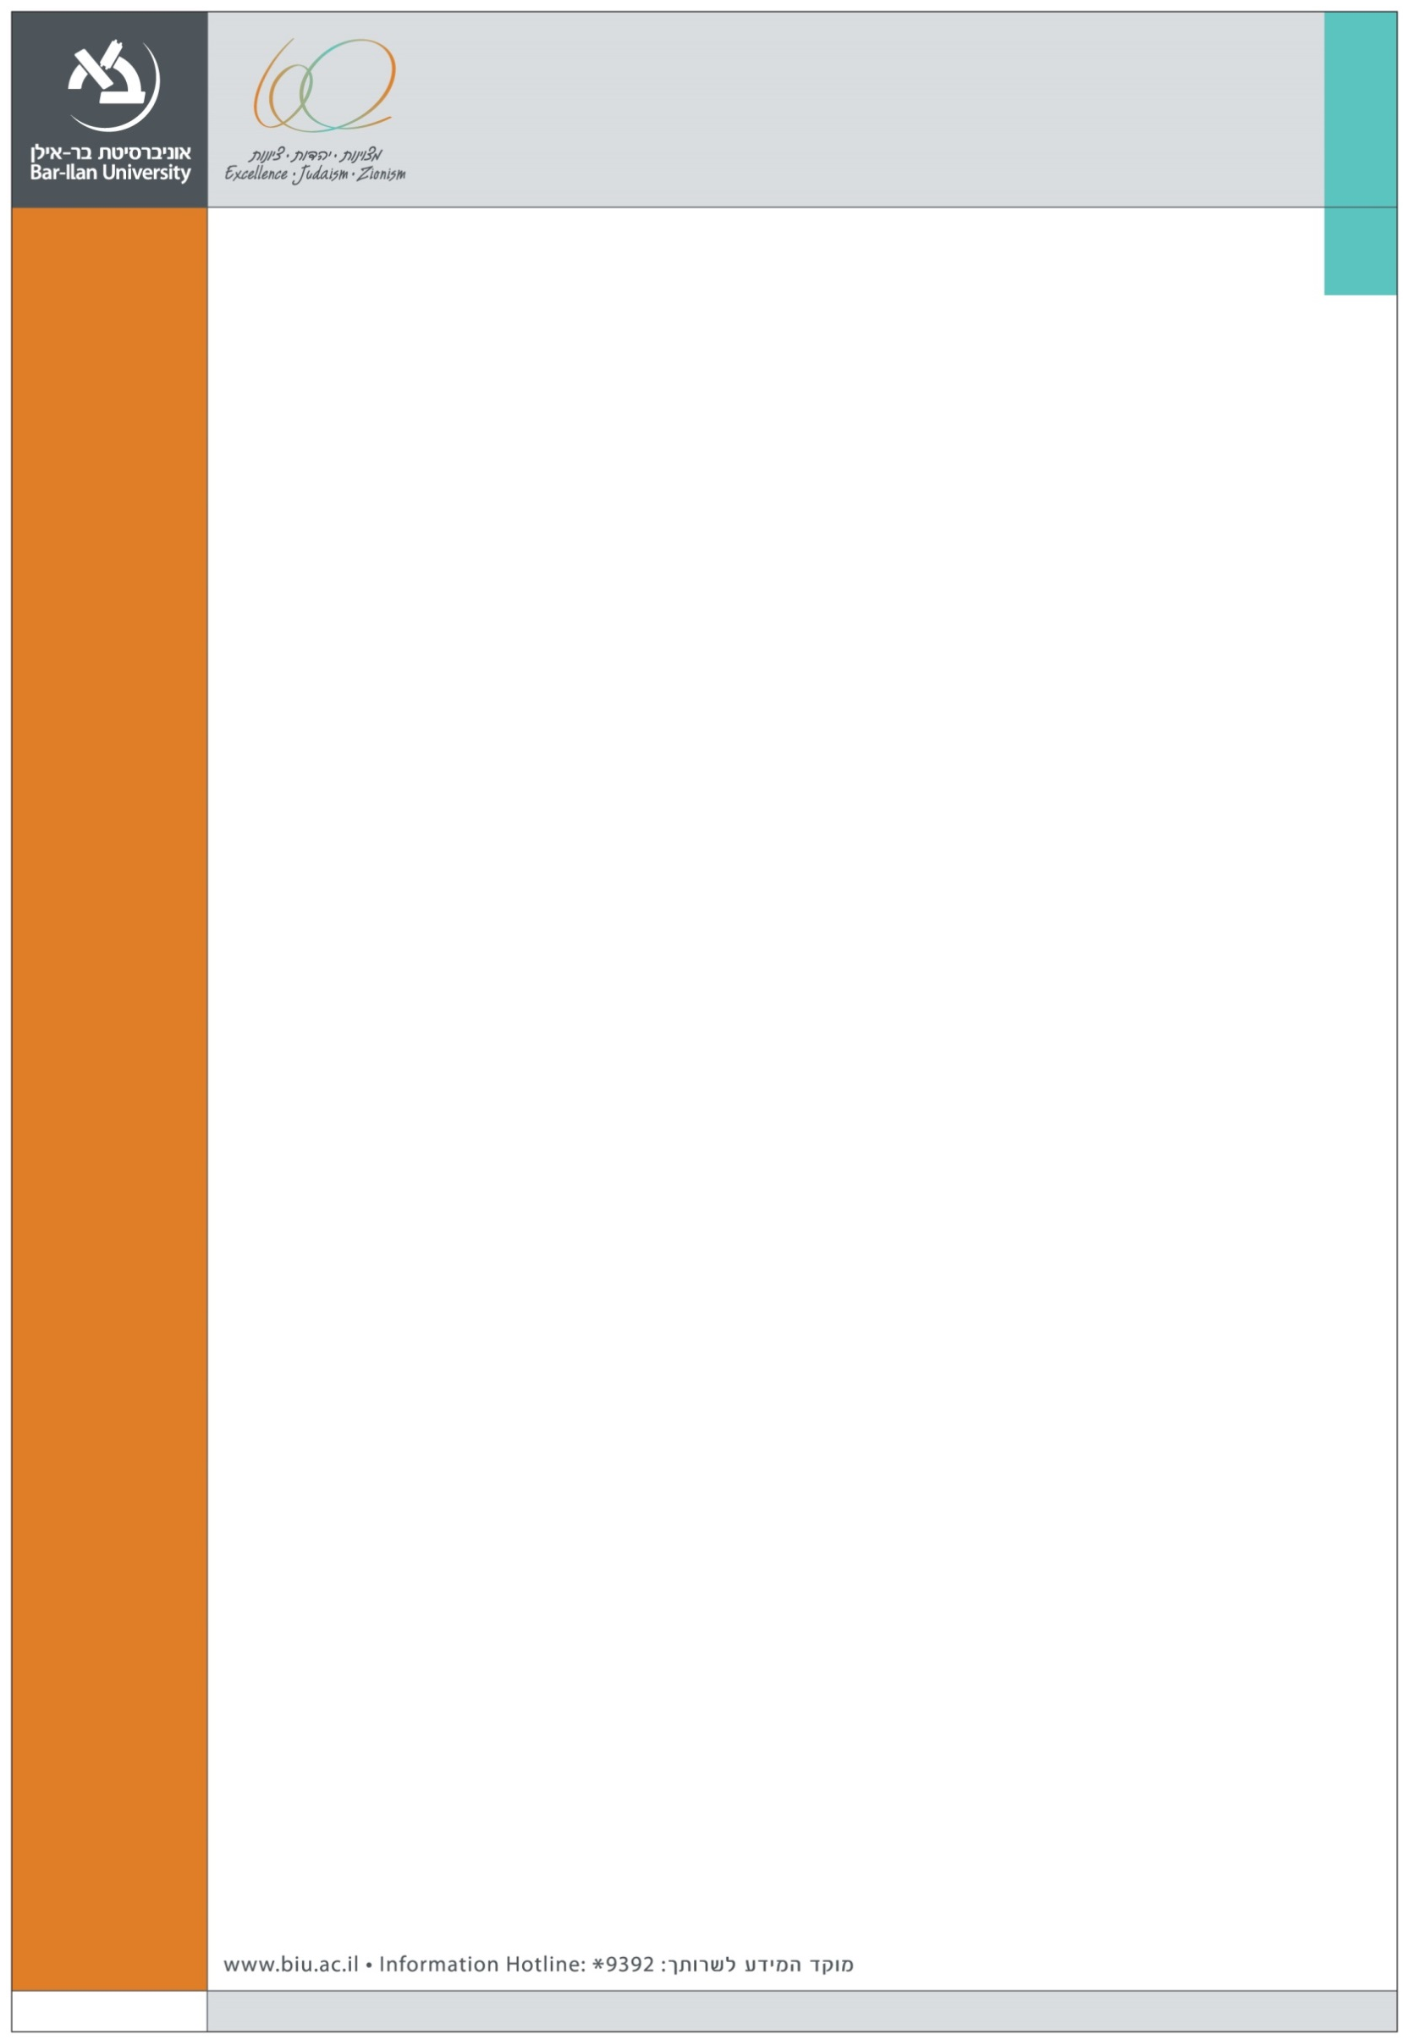
. We are happy to announce the following marketing seminar at the Graduate School of Business Administration
Speaker:

Dr. Efrat Aharonov-Majar
Technion

Title:

The Paradoxical Imitation of bad examples:
Exploration, imitation and experience

Abstract:

Studies of observational learning demonstrate that people tend to imitate successful others, and to avoid the mistakes performed by others. Yet, there are interesting exceptions to this rule; in some situations, people and organizations seem to intentionally imitate mistakes. One example is increase in sales of books that received negative reviews, in support of the saying “There is no bad publicity”. In the present research, we explored the relative importance of three factors that may contribute to this pattern of behavior: Inspired exploration, copycat imitation, and the likelihood that imitation will lead to a negative outcome. Our results indicate that when individuals have partial experience with feasible strategies, they are likely to explore bad strategies after observation of others’ mistakes. When the bad strategy is reinforcing most of the time, imitation is likely to persist.
One potential class of implications of the current results involves prediction of the expected effect of media campaigns and other methods of norm enforcement that try to reduce the risk of counterproductive behaviors by the description of costly mistakes
Tuesday, December 22 2015, 14:00
Seminar room (11), Ground Floor,
Economics and Business School Building (504)

