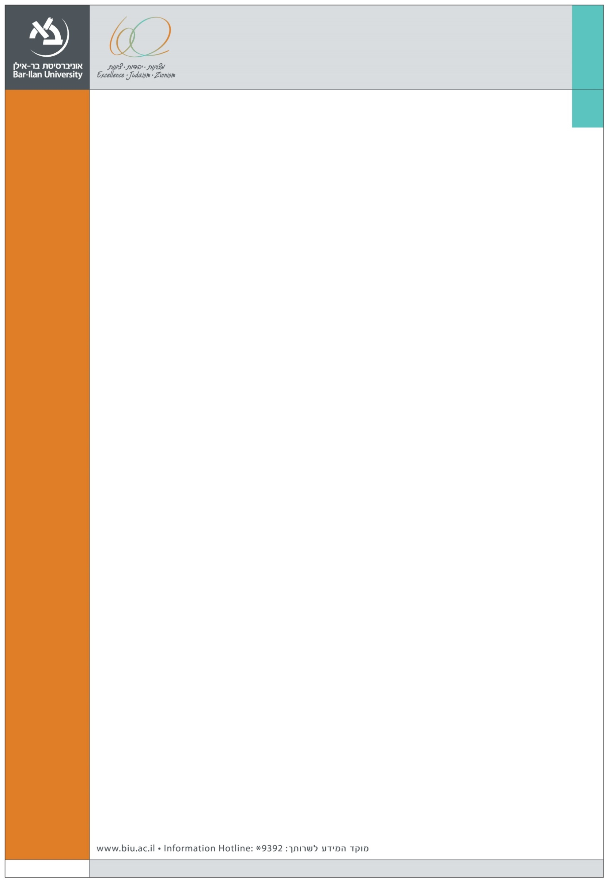
. We are happy to announce the following marketing seminar at the Graduate School of Business Administration
Speaker:

Dr. Nira Munichor
The Jerusalem School of Business Administration
The Hebrew University

Title:

The Influence of Time-Interval Descriptions on Goal-Pursuit Decisions

Abstract:

This paper examines how the description of the time interval allowed for goal completion affects goal-pursuit decisions. Six experiments show that consumers are more likely to pursue goals when the completion interval is described by durations (e.g., “two weeks from now”) instead of dates (e.g., “between today and December 15”). The experiments further find that dates lead people to focus more on the means or process required for goal achievement, whereas durations lead people to focus more on the outcomes of goal pursuit. Specifically, participants who consider a date (vs. duration) description focus and rely more on process-related considerations and less on outcome-related considerations when contemplating a goal, and are more sensitive to a change in the effort required to achieve the goal. Furthermore, participants are no longer more willing to pursue duration- (vs. date-) described goals when the outcomes are negative but the process is positive. Interval description has an attenuated effect when the target time interval is especially long and it is difficult to envision the specific process. These findings contribute to a better understanding of the factors that influence the initiation of goal pursuit.

Tuesday, January 12, 2016 14:00
Seminar room (11), Ground Floor,
Economics and Business School Building (504)

Faculty and graduate students are invited

