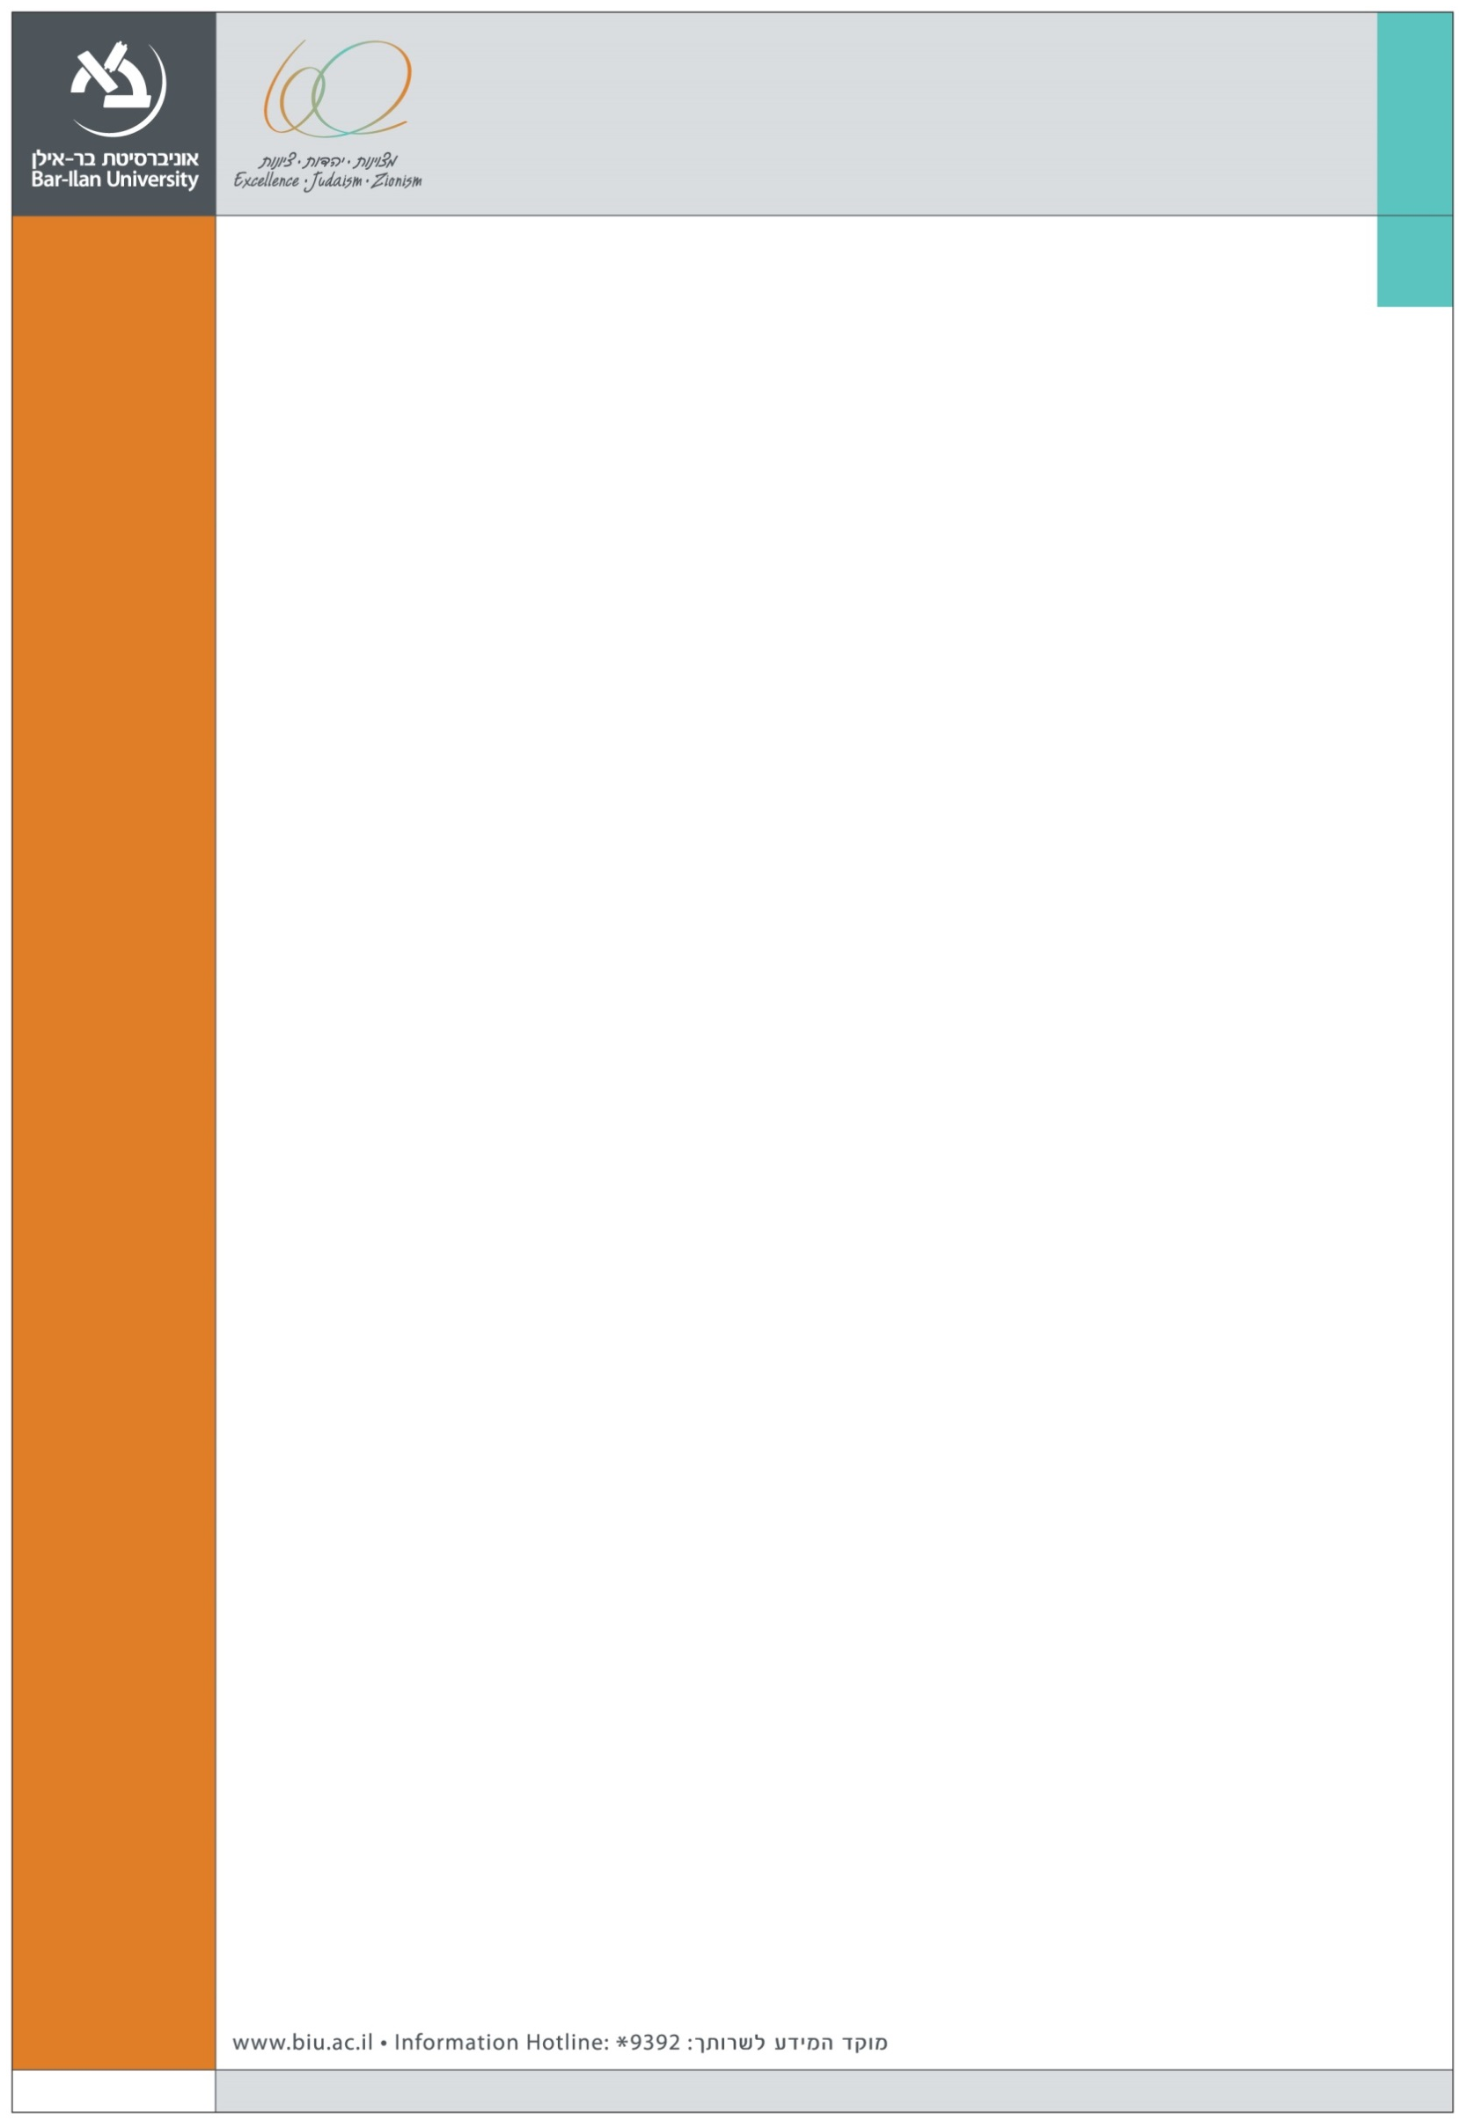
We are happy to announce the following Management and OB seminar at the Graduate School of Business Administration
Speaker:
Dr. Raveh Harush
University of Illinois at Urbana-Champaign
Department of Business Administration
Title:

Extending the Global Acculturation Model to Untangle the Culture Mixing Puzzle
Abstract:
Today’s globalized environment exposes people to culture mixing – mixing of iconic symbols of different cultures in the same space at the same time. Findings on individual exposure to culture mixing are seemingly inconsistent, providing evidence for both exclusionary and inclusionary responses. In this paper we focus on the growing phenomenon of culture mixing between global and local symbols and artifacts. We have generated a conceptual model to address who is likely to respond in what way to the mixed cultural environment, and why. To answer these questions we have built upon the global acculturation model, which proposes to explain individuals’ adaptation to the global environment by looking at the relative strength of their local and global identity. We extend this model by considering not only the two entities’ relative strength but also their balance – the degree of symmetry between identities’ strength. We propose that individuals with dominant (unbalanced) identity types (global or local) will exhibit negative and exclusionary responses to culture mixing, while individuals with balanced identity types (glocal or marginal) will exhibit positive and inclusive responses to culture mixing. We also incorporate the concept of bicultural identity integration (BII), to suggest that individuals with high identification with both cultures (glocals) with high BII will exhibit more inclusive responses than glocals with low BII. Theoretical and practical implications are discussed.

Tuesday, December 29, 2015 14:00
Seminar room (11), Ground Floor,
Economics and Business School Building (504)

