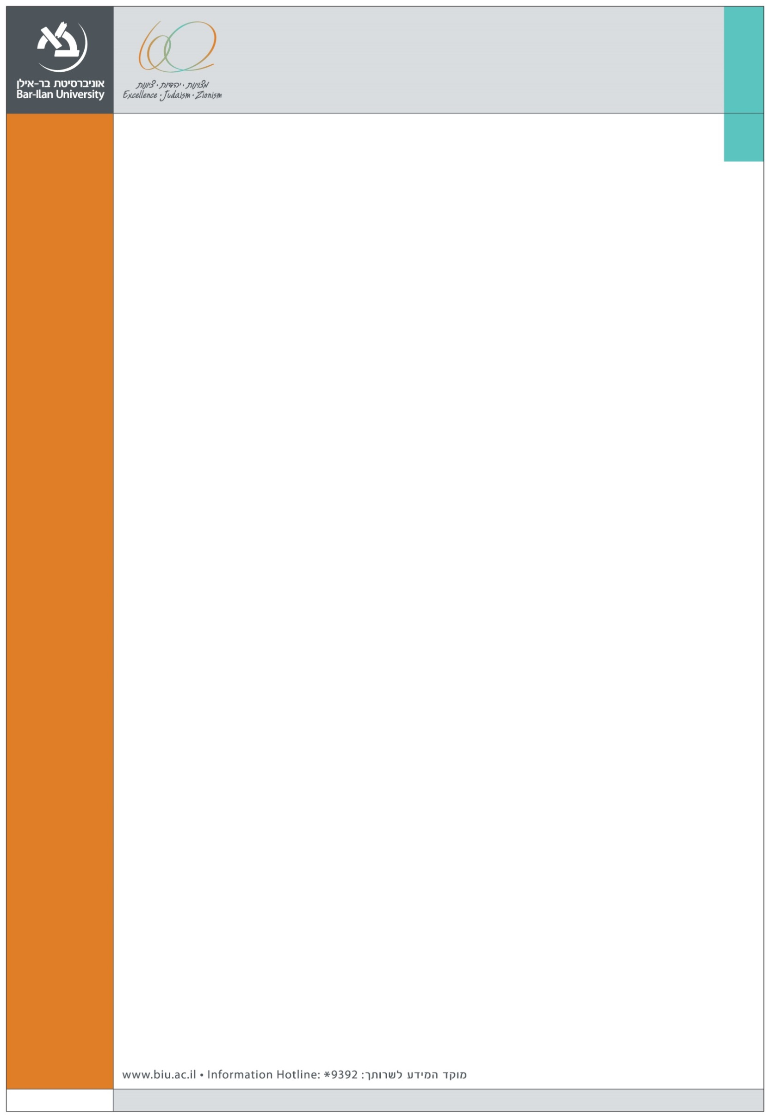
We are happy to announce the following Departmental seminar at the Graduate School of Business Administration

Speaker:
Dr. Erez Yaakobi
Ono Academic College and Bar-Ilan University

Title:
Managers' Evaluations of Individual, Group and Organizational Efficacies in Predicting Performance:
A Hierarchical Model

Abstract:
This study develops a conceptual framework for predicting three facets of employee performance (quality, innovation and efficiency),
based on individual (self and occupational efficacies), group (collective efficacy) and organizational (means efficacy) levels.
A sample of 109 managers evaluated their employees as well as group and organizational efficacies as predictors of employee
performance.
The results show that managers' evaluation of employees' self-efficacy accounted for most of the explained variance for all performance facets. Managers' evaluation of collective efficacy added incremental explained variance to general performance as well as to innovation performance and efficiency performance. Managers' evaluation of means efficacy (provided to employees) added incremental explained variance to general performance as well as to innovation performance and the efficiency of performance. Male managers differed from female managers in their predictions of employees' performance. Theoretical and practical implications for organizational behavior
are discussed.

Tuesday, January 19 2016, 14:00, Building (504)
Seminar room (11), Ground Floor, Economics and Business School Building (504)

