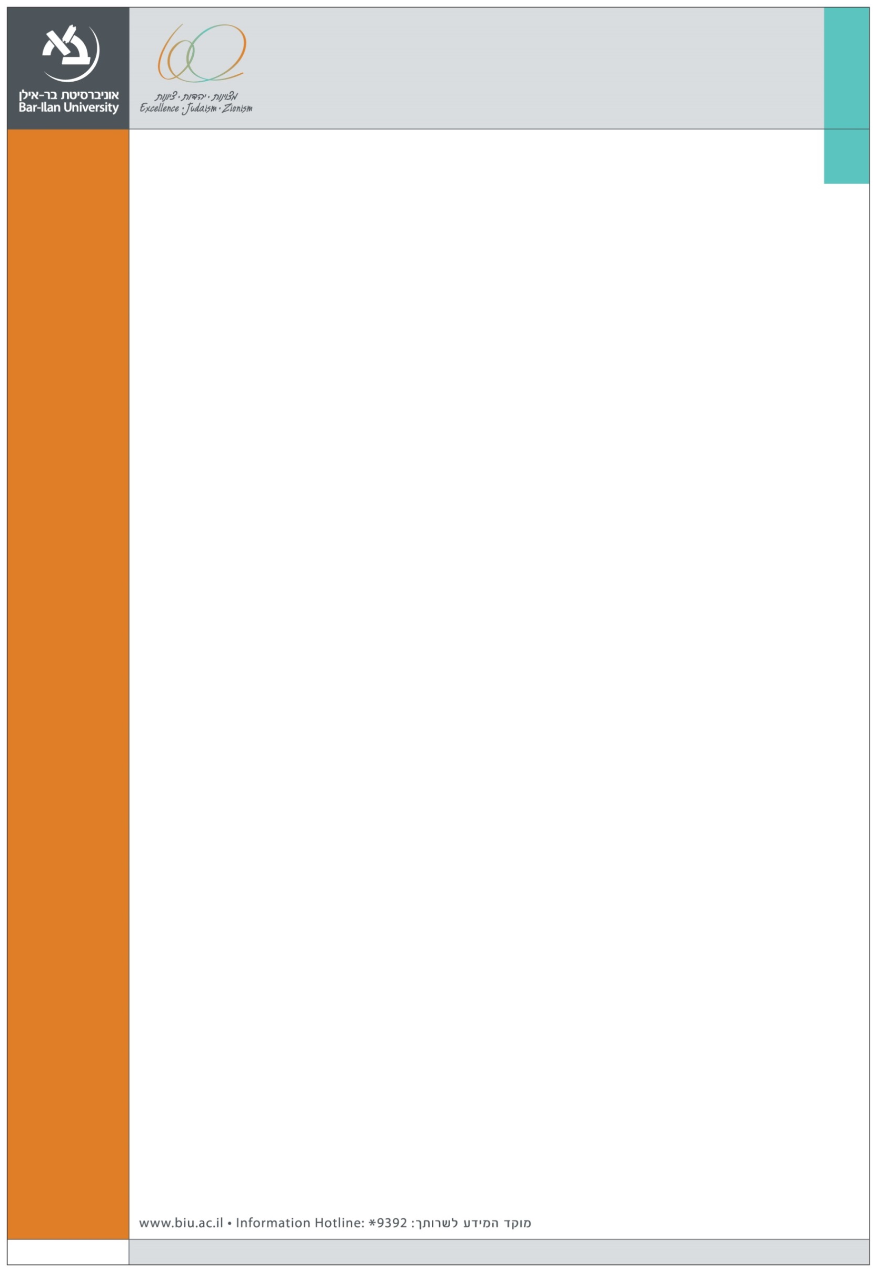

We are happy to announce the following Departmental seminar at the Graduate School of Business Administration

Faculty Blitz Seminar

Featuring the lecturers of the
Graduate School of Business Administration

This special seminar will host a “blitz” of short talks – each five minutes long – from the various lecturers of the Graduate School of Business Administration. Each lecturer will present one research project, idea or other relevant topic, that exemplify and represent their current research interests.

Join us for this exciting and stimulating seminar to get a glimpse of the variety of research projects carried out in our School.

Tuesday, March 1 , 2016, 14:00 Seminar room (11), Building (504)

