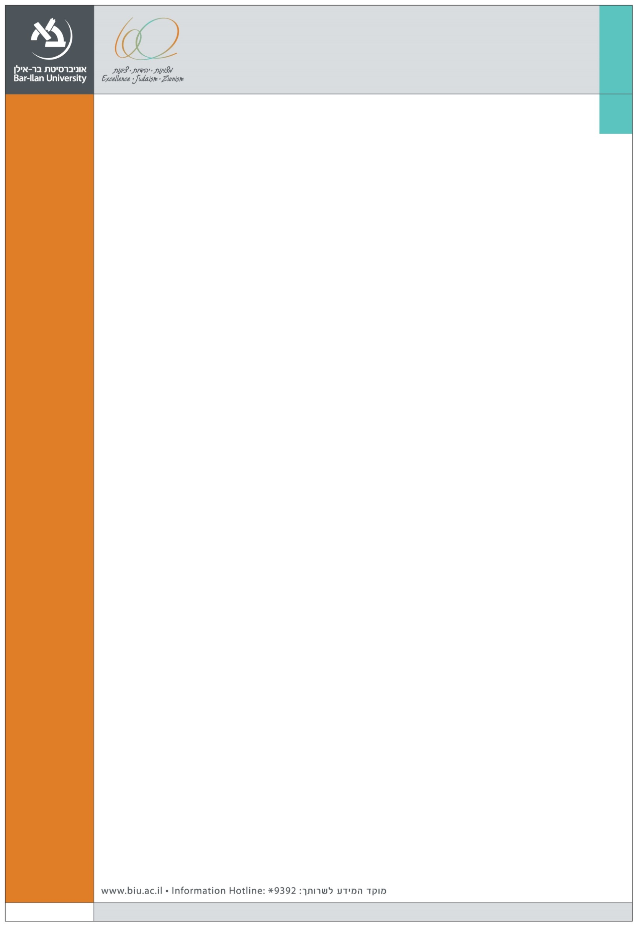
We are happy to announce the following Departmental seminar at the Graduate School of Business Administration

Speaker:
Prof. Oded Lowengart
Ben-Gurion University

Title:
A Non-Parametric Bootstrap Based Method for Heterogeneity Analysis

Abstract:
Grouping consumers into relatively homogeneous classes is of great importance for marketers since it enables them to develop specific products and marketing strategies to better cater these segments. Typically, marketing research projects that try to address these issues involve the gathering of several segmentation variables that might not be the "best" ones to segment the data as it might not capture all relevant heterogeneity.
A different, non-parametric, segmentation method that is based on the heterogeneity among consumers' perceptions of underlying product-related factors’ structure is proposed to address some of these issues that is based on identifying underlying, or latent, structure in the data. Finding a distribution of a second-moment, aggregate level, parameter enables to identify consumers into different segments. Specifically, by calculating of the distribution of a principle component based factor loadings using a bootstrapping method, consumers can be classified into homogeneous groups.

Tuesday, January 5 2016, 14:00, Building (504)
Seminar room (11), Ground Floor, Economics and Business School Building (504)

